Week 10: Notification Configuration

Screenshots for Guidance

Key:

* Anything with numbers = Click Path
* Anything highlighted in Green can be skipped
* Anything highlighted in Yellow should give you pause – you MAY need to change the settings for your particular class
* Anything highlighted in Red must be changed

**Configuring timing of Final Reminder notifications**

1. Navigate to Admin

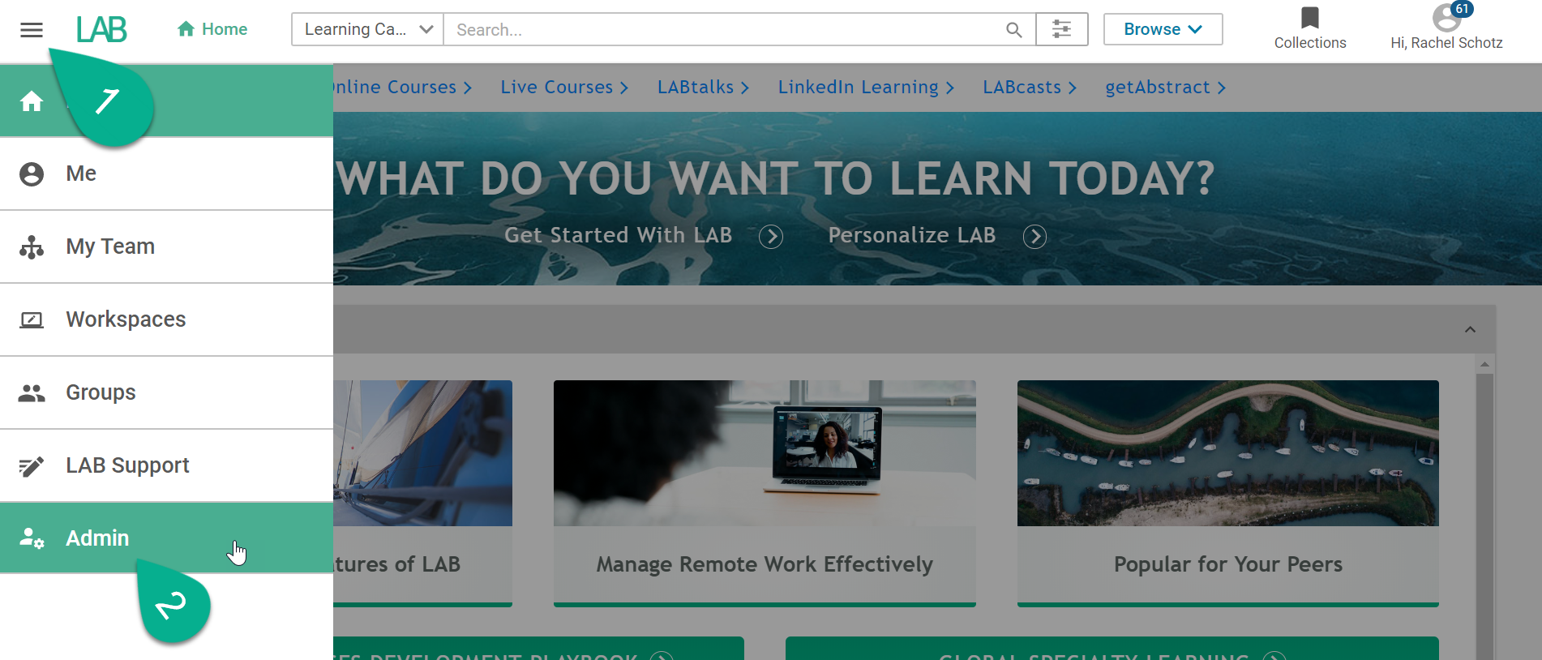

1. Get to Learning Admin

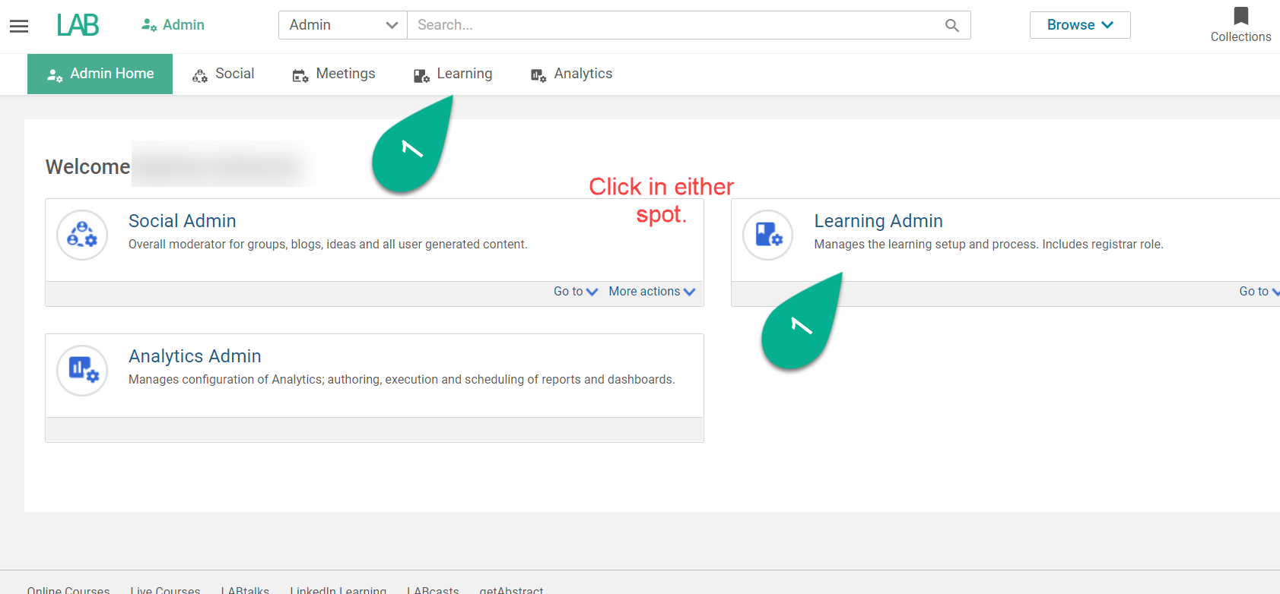

1. Search for a class.
   1. Navigate to Admin > Learning > Manage Classes > Classes
2. Select class to open Class Details page
3. While on the Class Detail’s Main page, scroll to bottom for ‘Availability Information’
4. Find ‘Class Reminder Before Start Date (days)’
   1. Enter number for days BEFORE event start date that you want notification to fire
   2. Start date is configured above in the Schedule Details section on Class Detials page

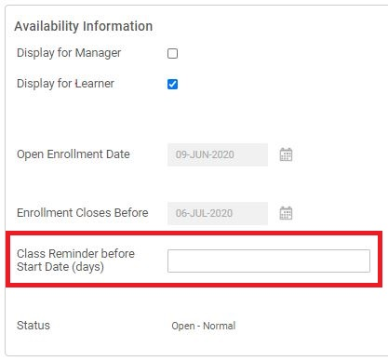

1. Click Save

**Enabling notifications for your class**

1. From the Class Details page navigate to the ‘Notifications’ tab (Follow steps 1-4 above to find Class page)

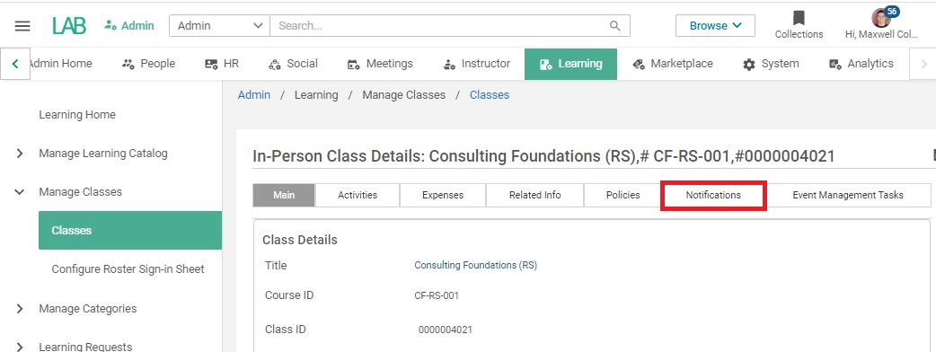

1. There are TWO PAGES of notifications for In-Person, Blended, and Virtual Classes
   1. Filled check boxes are enabled notifications
   2. Toggle check box to enable or disable notifications
   3. Enable *00 - FINAL Reminder - Instructor-Led Class* 
      1. If already enabled, leave enabled
         1. For Blended Classes enabled *00 - FINAL Reminder - Blended Class*
         2. For Virtual Classes enabled *00 - FINAL Reminder - Virtual Class*
   4. Enable or Disabled *01 - Standard Class Reminder - Instructor-Led Class*
      1. This is a standard class reminder that is sent 21 days before your event but L&D Coordinators can’t change the look or text of this notification

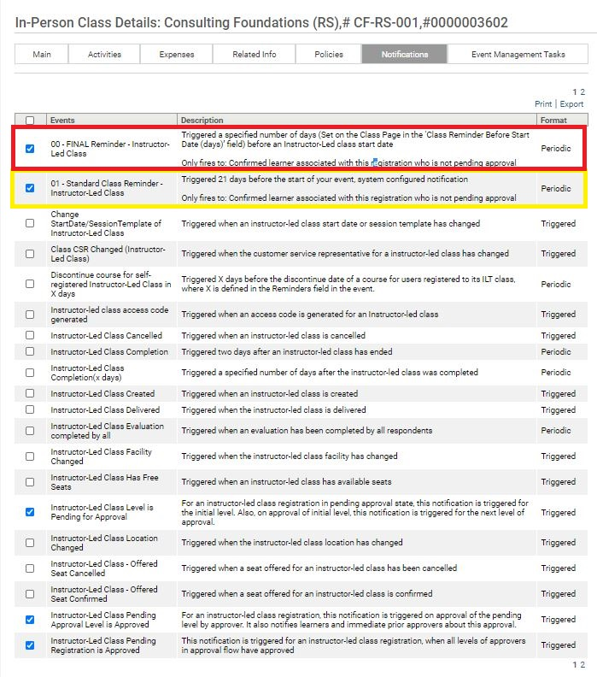

*01 - Standard Class Reminder - Instructor-Led Class* is the reminder notification that the L&D Coordinator WON’T have control over and is configured at the system level. Check box if you want notification to be able to be fired

*00 - FINAL Reminder - Instructor-Led Class* is the reminder notification that the L&D Coordinator WILL have control over and is configured and fired based on the ‘Days before Start date’ you configured in Step 6

1. Click Save at the bottom right of the page
2. Now your reminder notification is enabled and you’ve set it to fire a number of days before the start date of your event
   1. To disable at anytime, follow steps 1-3 and uncheck the *Instructor-Led Reminder(x days)* event on the notification tab of your event

**Configuring Reminder notification for your class**

1. Navigate to the Notifications Tab on your event
   1. Follow steps 1-4 of ‘Configuring timing of Final Reminder notifications’ above to find Class page
   2. Follow step 1 of ‘Enabling notifications for your class’ above to find the Notifications tab
2. Go to the ‘Notifications Templates’ section
3. Click ‘000-Live_Final_Reminder_Template’

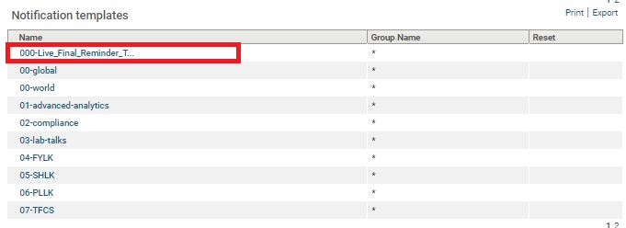

1. A ‘New Template’ window will open
2. Click the ‘Advanced Options’ button

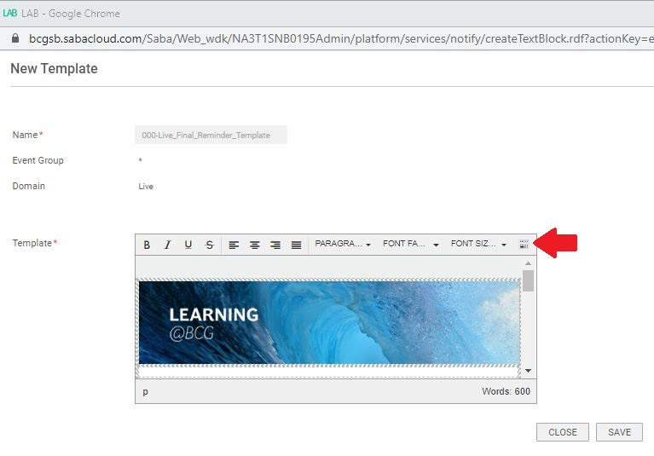

1. To make full screen, click the  full screen toggle button
   1. To save, you’ll need to click this button when you’re finished configuring

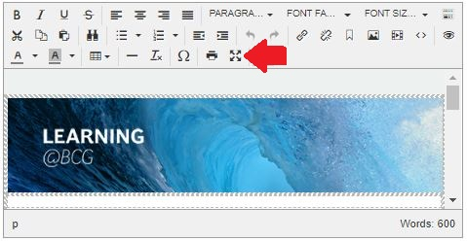

1. Now with Full Screen Mode enabled, you can see the entire notification and edit it how you like!
   1. TO SAVE: you must exit full screen mode by clicking the  full screen toggle button again
   2. Keywords are any words with @text@
      1. Keywords pull in information from your event
      2. Do not edit keywords or else they will break
   3. Class Page hyperlink has been added, feel free to move or add it wherever you like
   4. Edit as much or as little as you’d like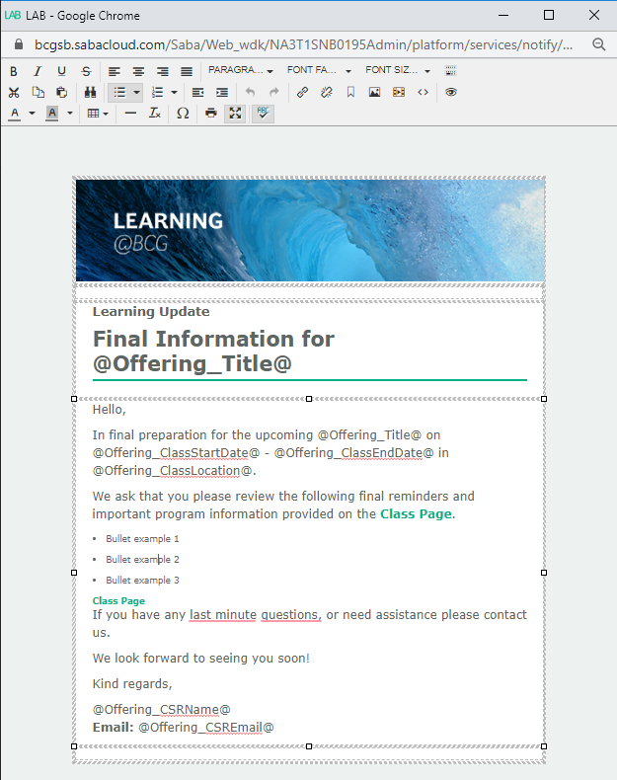
2. TO SAVE: you must exit full screen mode by clicking the  full screen toggle button again
3. Click Save
4. Notification will fire from [Learning@BCG.com](mailto:Learning@BCG.com)
   1. No control over FROM field

Successfully fired notification from SANDBOX (tester uses dark mode in Outlook, that’s why the message is dark)

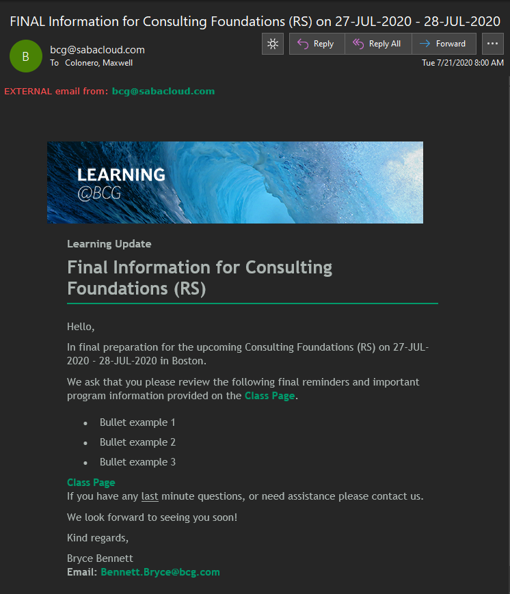

Congratulations! You just configured your very own Final Information notification and timing of the notification!

**Firing an Adhoc Notification for your class**

* + - 1. From the Class Details page (Follow steps 1-4 above to find Class Details page)
      2. On the Main tab scroll to the bottom of the page and find the ‘Send Notification’ button



* + - 1. Send Notification window should pop open with 3 main fields to configure

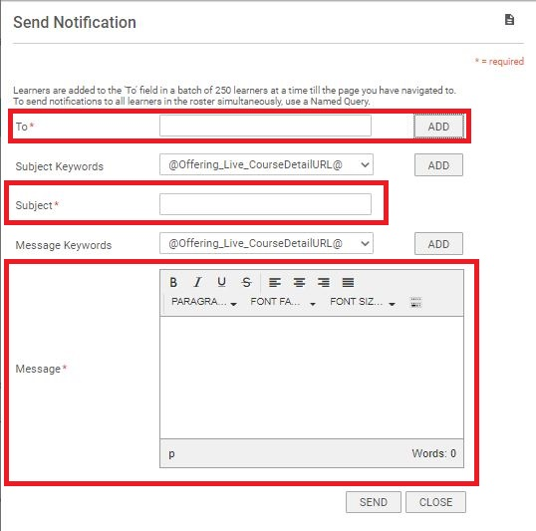

* + - * 1. **TO**

Simply add email addresses with semicolon as delimiter

Or Click ‘Add’ to use a Name Query to pull in a group of users related to your specific class

Named queries are how SABA identifies and groups certain users based on their status, profile, etc.

Recommendation: USE – ‘List of the Learners in a Class’

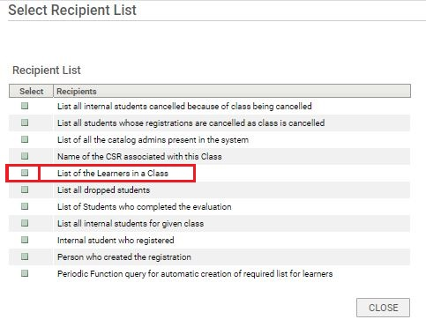

Once you select your named query the ‘Recipient List’ window will close and the TO field will populate with all users’ emails that fit that criteria for your class

You can still edit the TO field after you add a Name Query or even add another named query and it will add the of all the already added email addresses

* + - * 1. **SUBJECT**

Simply add your preferred Subject for the email

And/or click through the ‘Subject Keywords’ drop down to use a Keyword to pull in an attribute related to your specific class like title, Start date, End date, etc

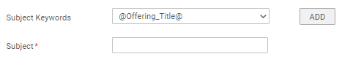

Select Keyword

Recommended Keywords

Class Title - @Offering_Title@

Class Start Date - @Offering_ClassStartDate@

Class End Date - @Offering_ClassEndDate@

Click Add

Subject will populate with the Keyword

You can still edit the SUBJECT field after you add a Keyword or add multiple Keywords

* + - * 1. **MESSAGE**

Simply add your preferred Message for the email in the message box

Note, there is not as much formatting with this notification, so it will show as plain text

And/or click through the ‘Message Keywords’ drop down to use a Keyword to pull in an attribute related to your specific class like title, Class URL, Start date, End date, etc

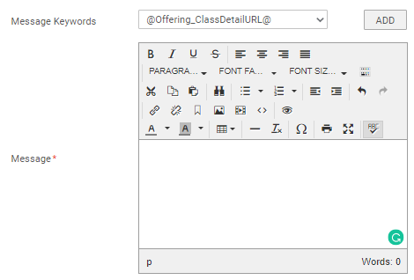

Select Keyword

Recommended Keywords

Class Title - @Offering_Title@

Class Start Date - @Offering_ClassStartDate@

Class End Date - @Offering_ClassEndDate@

Class Detail URL - @Offering_ClassDetailURL@

Click Add

Message will populate with the Keyword

You can still edit the MESSAGE after you add a Keyword or add multiple Keywords

**Advanced Configuring – adding a Class Page hyperlink**

Select @Offering_ClassDetailURL@

Click Add

URL populates within the message

Highlight the populated URL (this is specific to your class) and copy/cut the URL

Click the ‘Insert/Edit link’ button

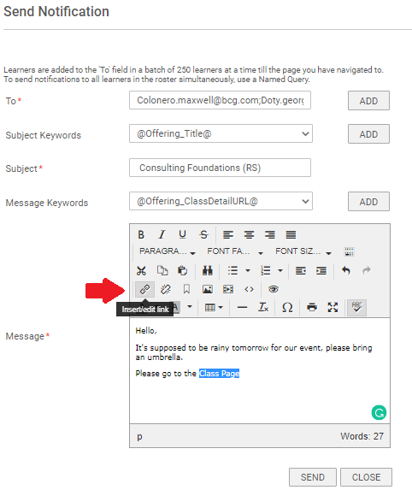

Insert Link window will open

Paste URL into URL

Set ‘Text to Display’ with what you’d like displayed in the email

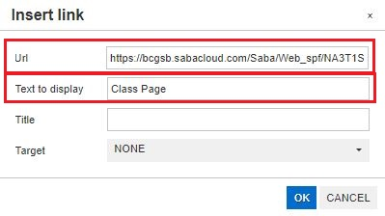

Hit OK

Hyper Link is now inserted in your message

* + - 1. You have now configured the 3 required fields to send a Adhoc Notification

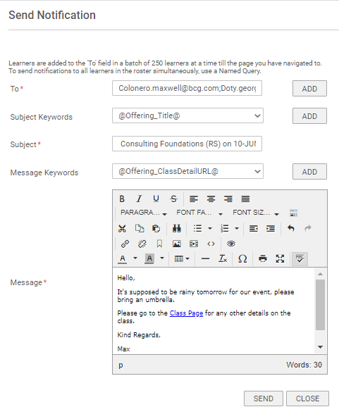

* + - 1. Review your email
      2. Click Send
         1. Notification sends immediately as soon as you hit send
         2. Notification will fire from the Learning@BCG.com

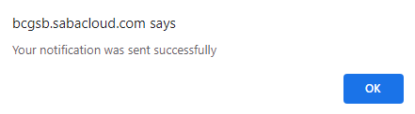

* + - 1. Notification fired from SANDBOX (tester uses dark mode in Outlook, that’s why the message is dark)

